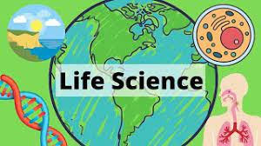

**Welcome to 7th Grade Life Science!**

My name is Ms. Kristina Istre (pronounced “East”) and I am teaching 7th grade Life Science this year. I am proud to say that I have been teaching for twenty-seven years. In addition, I am the Georgia Science Teacher Association Middle School President.  I am very excited to again be at AR Johnson teaching science, and I know this will be a great year!

     I have a 24-year-old son who recently graduated Georgia Southern University with a Computer Engineering Degree. In addition, I have an identical twin sister, Ms. Legoas, who works for the University of Georgia as a 4H Agent. In my free time I enjoy shopping, reading, doing various arts and crafts, and watching movies.

    I truly believe that in order to give your child the best education possible, it takes a team approach.  The student, parents, and teacher must work together and communicate in order to provide the students with the best education possible.  So, if there is ever a question or concern, please send me a message through the Remind app (look on my syllabus or on my ARJ web page for directions, if you aren’t registered yet), a note in the agenda, or an email at istrekr@BOE.Richmondk12.ga.us and I will respond as soon as possible.  Please be aware though that some days I may not check my email until the end of the day because my first priority is giving your child my full attention.  However, I assure you I will respond within 24 hours.

Thanks in advance for your cooperation, and I look forward to a great year as AR Johnson Panthers!

Ms. Kristina Istre

A.R.J. 7th grade Life Science Teacher   
Georgia Science Teachers Assoc. President